**Chapter I**

**NTRODUCTION**

**Background and Rationale**

Research information management systems (RIMS) may support the transparent aggregation, curation, and utilization of data about institutional research activities. According to OCLC Research, research information management (RIM) is "the aggregation, curation and utilization of information about research and is emerging as a part of scholarly communications practice in many university libraries" (OCLC Research, 2022). These digital platforms can potentially help universities monitor their research processes and identify areas for improvement.

The OCLC Research report "Research Information Management in the United States" provides documentation of RIM practices at US research universities, presenting an examination of RIM practices, goals, stakeholders, and system components (Bryant et al., 2021). This study suggests that research information management is becoming an increasingly important area of investment in US research universities.

The global shift toward digital transformation in higher education has fundamentally reshaped how institutions manage research activities. Castro-Benavides et al. (2023) conducted a comprehensive multivocal literature review revealing that higher education institutions are undergoing significant evolution toward digital university models requiring not only technology adoption but organizational strategic transformation encompassing information systems, processes, and human factors. Their analysis demonstrated that universities implementing comprehensive digital strategies showed marked improvements in research management efficiency and stakeholder satisfaction.

Academic institutions are increasingly implementing systems that track publications and scholarly activities of faculty. Research administration software specifically designed for higher education has evolved to meet institutional needs, with various software solutions catering to different aspects of research management, from grant applications to compliance tracking (ListEdTech, 2024). These systems are increasingly recognized as essential infrastructure for maintaining competitive research programs in modern universities.

Some modern universities have adopted web-based electronic research administration systems to help streamline research processes. The University of Pennsylvania's PennERA (Penn's Electronic Research Administration system) serves as an example of this approach as "a suite of web-based applications that streamline processes and provide more efficient tools for handling pre- and post-award administrative tasks related to the sponsored projects" (University of Pennsylvania, 2025). PennERA functions as "a full life-cycle system for research project development, support, and management," which illustrates the potential comprehensive nature of modern research tracking systems.

Similarly, the University of Connecticut utilizes InfoEd for proposal tracking, which includes "the ability to track project funding status, research compliance approval status and requested/awarded revenue" (University of Connecticut, 2025). These systems showcase features that may help address some of the challenges identified at Eastern Samar State University: providing visibility into research status, enabling tracking capabilities, and offering monitoring functions.

The advancement of workflow automation technology has created significant opportunities for improving research management processes. According to ProcessMaker (2024), automation in educational institutions can reduce process touchpoints dramatically, with some universities experiencing reductions from 40 to 1 touchpoint, thereby reducing workload on educators by up to 13 hours per week. Element451 (2023) emphasizes that workflow automation in higher education eliminates manual data entry and touch points during daily work processes, boosting time management and efficiency by handling administrative details automatically.

Research Information Management encompasses "the ecosystem of activities and technologies that allow a university to track all of its research activities and outputs, including faculty activities, grant applications, funding, equipment, facilities, press and PR, and societal impacts" (West Arete, 2023).

At Eastern Samar State University, students currently have limited ways to check their research proposal status after submission. They often need to visit advisers personally to inquire about reviews or required changes. Faculty advisers manage multiple student proposals using paper files, which can make it challenging to organize submissions and track which students need attention. Administrators can typically only obtain research progress information by consulting individual faculty members.

The development of this Web-Based Automated Research Approval and Submission System seeks to help address some of the tracking and monitoring challenges in research management at Eastern Samar State University. The proposed system would potentially allow students to see where their research proposals are in the approval process and receive updates on their progress. Faculty might be able to more easily check which students have submitted what, and administrators could potentially monitor research activities from a centralized location.

Without adequate tracking systems, students and faculty may spend additional time on status inquiries, and important deadlines could potentially be missed. The current system at Eastern Samar State University appears to provide limited visibility into the research approval process. Students seem to have few options for tracking their progress, advisers may find it challenging to monitor multiple submissions efficiently, and administrators appear to have restricted overview of institutional research activities. This apparent lack of tracking and monitoring capability represents one of the main challenges that may affect the research approval workflow.

Web-based tracking systems may offer certain advantages over traditional methods. Modern research platforms can potentially show where each proposal is in the

approval process, send automatic updates when status changes, and provide dashboards that could give stakeholders the information they need. These systems might support greater transparency and efficiency in research management, potentially addressing some of the issues identified in traditional paper-based systems.

**Objectives of the study**

The study generally aims to develop and implement a web-based automated research approval and submission system that facilitates the research proposal workflow from title submission through final panel evaluation, reducing processing time and improving document tracking for students, faculty, and administrators at Eastern Samar State University. Specifically, this study seeks to:

1. To design and develop a user registration module using PHP and MySQL database that allows students to input their profile information, college affiliation, and academic details with administrative verification functionality.
2. To create a research title submission feature using a document upload system with automated in-system notification that enables students to upload proposal documents and receive real-time notifications for approval or revision requirements.
3. To implement a sequential chapter submission workflow using a progressive form system that enables students to submit Chapters 1 through 5 in order, with each chapter requiring adviser approval through a review interface before proceeding to the next chapter.
4. To establish a role-based collaborative commenting system using threaded discussion functionality that allows admin-assigned panel members to provide feedback on chapters only after the adviser has approved Chapter 3, enabling panel review during the later stages of proposal development.
5. To integrate real-time notification mechanisms using in-system alert functionality that informs users about submission status changes, new comments, pending reviews, and approval decisions through website notifications.
6. To evaluate the developed system through alpha and beta testing phases using the ISO/IEC 25010:2011 Software Evaluation Questionnaire for assessing functional suitability, performance efficiency, compatibility, reliability, and security, and the IBM Computer System Usability Satisfaction Questionnaire (CSUQ) for assessing system usability and user satisfaction.

**Scope**

The Web-Based Automated Research Approval and Submission System is created to make the whole process of submitting, reviewing, and approving research proposals. Students and faculty can submit proposals online, check how things are progressing, and get feedback from reviewers, all in one place.

The key features of the system include:

1. Account creation for students, including input of group members and college information.
2. Uploading and reviewing of research titles with panel approval.
3. Step-by-step submission of Chapters 1 to 5 with adviser review.
4. Notifications for approval or revisions needed.
5. Final panel submission for reviewed chapters.
6. Document tracking and status monitoring throughout the approval process.
7. The system provides built-in messaging for direct communication between researchers and reviewers.
8. Role-based access for students, faculty advisers, panel members, and administrators.

**Limitations**

1. Users must have an active internet connection to access this web-based platform.
2. While the system manages submission and tracking, the actual review and decision-making still rely on human evaluators.
3. File size limits may be implemented to prevent server overload.
4. The system includes basic security features but may not be completely immune to cyber threats without further enhancements.
5. The system cannot automatically verify the academic integrity or originality of submitted research proposals.
6. System performance may vary across different web browsers and requires modern browser capabilities for optimal functionality.
7. The system operates as a standalone platform and does not integrate with existing university management systems or external academic databases.

**Significance of the Study**

The development of the Web-Based Automated Research Approval and Submission System will benefit:

**Students**, this system helps at Eastern Samar State University by enabling the digital submission of research proposals, reducing paperwork and confusion. The clear submission process makes it easier for students to understand what's required, so they can put more energy into improving the quality of their research instead of getting bogged down by administrative details. Students receive timely notifications about their submission status and can track their progress throughout the approval process.

**Researchers**, the system reduces manual work and provides a central place for storing research documents and feedback. Researchers can easily monitor the progress of their proposals, reducing the need for constant status updates. Plus, with all evaluations stored digitally, they have a valuable resource to help them improve future submissions.

**Future researchers**, the system creates a consistent process and clear evaluation standards, setting expectations for new projects. The stored information gives future researchers the opportunity to learn from past submissions and better understand what makes a proposal successful. This knowledge base helps maintain research quality and reduces learning curves for new researchers.

**Faculty**, the system organizes research proposals and provides structured review templates, reducing time spent searching for documents or checking submission statuses. This gives faculty the opportunity to offer more detailed feedback and stay more connected with the research activities happening in their department. Faculty members can access submissions from any location, improving flexibility in the review process.

**Research administration**, digital workflows replace paper-based processes, reducing lost documents and enabling quick information retrieval. With automated notifications, administrators don't have to follow up manually as often, giving them more time to focus on helping and guiding researchers. The system provides comprehensive tracking and reporting capabilities that support institutional decision-making and compliance requirements.

**Academic institutions**, Eastern Samar State University and similar institutions benefit from standardized procedures that promote fairness and consistency across departments. Improved efficiency can lead to more completed research projects and better institutional standing, while also providing useful data on research activities for planning and resource allocation. The system enhances the university's reputation by demonstrating commitment to modern, efficient research management practices.

**DEFINITION OF TERMS**

The following terms are defined operationally as used in the study Web-Based Automated Research Approval and Submission System:

**Automated Notification Mechanisms** - Digital alerts and updates that automatically inform users about submission status changes, new comments, pending reviews, and approval decisions without requiring manual intervention from administrators.

**Chapter Submission Workflow** - A sequential digital process that enables students to submit research chapters (Chapters 1 through 5) in order, requiring adviser approval before proceeding to the next chapter submission phase.

**Collaborative Commenting System** - A role-based digital feature that allows advisers to provide feedback through threaded discussions on Chapters 1-3, while panel members can comment on all chapters (1-5) only after students have completed their proposal oral final defense.

**Document Tracking** - The systematic monitoring and recording of research proposal documents throughout the approval process, providing real-time visibility into submission status and location within the workflow.

**Panel Evaluation System** - A digital platform feature that allows faculty panel members to review completed research proposals and provide structured feedback through comments only after students have completed their proposal oral final defense.

**Research Information Management (RIM)** - The aggregation, curation, and utilization of information about research activities, emerging as part of scholarly communications practice in university libraries to support institutional research oversight.

**Research Information Management Systems (RIMS)** - Digital platforms that support the transparent aggregation, curation, and utilization of data about institutional research activities, helping universities monitor research processes and identify areas for improvement.

**Research Title Submission Feature** - A digital process that allows students to upload proposal documents for their research titles and receive automated notifications regarding approval or revision requirements from panel members.

**Role-Based Access** - A system security feature that provides different levels of access and functionality for students, faculty advisers, panel members, and administrators based on their specific roles within the research approval process.

**User Registration System** - A digital process where students can input their group members, college affiliation, and academic details, with administrative verification required before gaining system access.

**Web-Based Automated Research Approval and Submission System** - A comprehensive digital platform designed to facilitate the research proposal workflow from title submission through final panel evaluation, reducing processing time and improving document tracking for students, faculty, and administrators at Eastern Samar State University.

**Chapter II**

**REVIEW OF RELATED SYSTEMS**

This chapter presents a comprehensive review of current systems, technologies, and research related to research approval and submission processes. The literature examined includes studies on digital research management systems, workflow automation platforms, and technological frameworks from both international and Philippine contexts published from 2020 onwards. This review establishes the foundation for the development of the Web-Based Automated Research Approval and Submission System by identifying contemporary approaches, emerging challenges, and innovation opportunities in academic research management.

The global shift toward digital transformation in higher education has fundamentally reshaped how institutions manage research activities. Castro-Benavides et al. (2023) conducted a comprehensive multivocal literature review revealing that higher education institutions are undergoing significant evolution toward digital university models requiring not only technology adoption but organizational strategic transformation encompassing information systems, processes, and human factors. Their analysis demonstrated that universities implementing comprehensive digital strategies showed marked improvements in research management efficiency and stakeholder satisfaction.

Building on this foundation, García-Morales et al. (2021) examined the transformation of higher education after the COVID disruption, highlighting how higher education institutions underwent radical transformations driven by the need to digitalize education and training processes in record time. Their research emphasized that universities had to overcome significant barriers including limited technological capabilities among faculty while striving to provide high-quality education in a scenario of digital transformation and disruptive technological innovations.

Complementing these findings, Li et al. (2023) investigated enterprise digital transformation and information transmission efficiency, finding that digital transformation significantly improves information transmission efficiency while reducing administrative burden. Their research revealed that organizations implementing digital workflows experienced substantial improvements in data accuracy, process transparency, and stakeholder communication—benefits directly applicable to research proposal management systems.

Kayanja (2025) explored the shift toward fully automated and paperless systems in higher education, particularly examining institutions in developing regions. The study emphasized how digital tools improve access to learning resources for students while reducing administrative burdens for educators, allowing more time for innovative teaching practices and streamlined workflows for administrators.

The assessment of digital transformation maturity has become crucial for institutional success. Bravo-Jaico et al. (2025) conducted a correlational analysis examining how different stakeholders perceive various dimensions of digital

transformation in higher education institutions. Their research found that digital maturity varies significantly according to institutional actors and the specific dimensions considered, suggesting that comprehensive transformation requires stakeholder-specific strategies.

The advancement of workflow automation technology has created significant opportunities for improving research management processes. Element451 (2023) documented how higher education workflow automation eliminates manual data entry and touch points during daily work processes, boosting time management and efficiency by handling administrative details automatically. Their research showed that automated systems can handle activities like replacing paper forms, sending notifications, generating reports, and updating records without compromising data integrity.

FlowForma (2025) emphasized that digital transformation and process automation in education enables colleges and universities to streamline complex processes, from admissions and curriculum management to finance and compliance. Their analysis revealed that institutions implementing automation experience less administrative burden, faster decisions, and better experiences for both students and staff.

Paul et al. (2024) provided a multidisciplinary perspective on digital transformation, highlighting how organizations are compelled to pursue innovation in response to societal demands. Their research demonstrated that digital transformation captures and integrates data from various sources, often on digital platforms and ecosystems, combining different types of data to provide comprehensive insights for decision-making.

Suárez-Álvarez and Pham (2025) developed a theoretical-methodological framework for assessing digital transformation maturity levels in higher education institutions. Their model identified eight dimensions based on organizational processes in higher education, providing institutions with tools to evaluate and improve their digital transformation initiatives.

Digital Adoption Team (2024) provided a comprehensive overview of digital transformation in higher education, emphasizing how institutions implement machine learning to streamline manual tasks, maximize resources, and automate activities. Their analysis showed that successful digital transformation includes personalized learning experiences, flexible online courses, and automated administrative processes.

The Philippine higher education landscape presents both significant opportunities and unique challenges for digital research management implementation. The World Bank (2022) conducted a comprehensive analysis of digital transformation in Philippine higher education, revealing that pre-pandemic, the sector was already using digital technologies to respond to digital age demands. During the pandemic, institutions accelerated their use of digital technologies to transform teaching, learning, research, and administration.

Government support for digital transformation has been substantial and strategic. The Commission on Higher Education (2020) issued comprehensive guidelines for implementing flexible learning, demonstrating institutional commitment to digital

transformation that addresses systemic challenges in academic administration. These guidelines provided frameworks for institutions to adapt their research and academic processes to digital platforms.

The Department of Information and Communications Technology (2024) has played a crucial role in supporting the education sector's digital transformation initiatives. DICT's programs focus on promoting digital literacy and upskilling teachers in cybersecurity and other digital competencies, creating a supportive environment for comprehensive digital research management systems.

UNESCO (2023) conducted a comprehensive case study on technology in education in the Philippines, examining how educational institutions have integrated digital technologies to address infrastructure challenges and improve service delivery. The study highlighted both opportunities and barriers in implementing comprehensive digital transformation initiatives.

Individual institutions have demonstrated leadership in digital transformation. Lallana (2023) documented the University of the Philippines' efforts in leading transformation into a digital national university, emphasizing how digital transformation changes the way institutions educate students and manage research processes.

The University of the Philippines (2024) implemented Flagship Program 10 focusing on digital transformation, representing a comprehensive approach to modernizing university processes and information systems. This initiative demonstrates institutional commitment to systematic digital transformation across academic and administrative functions.

Policy-level support has been institutionalized through various government initiatives. The Philippine Institute for Development Studies (2024) emphasized the importance of digital transformation and technology in tertiary education and upskilling, highlighting how educational technology companies provide scalable solutions for Philippine educational institutions.

Vilches et al. (2021) examined how Philippine higher education institutions delivered digital transformation initiatives, particularly during the pandemic period. Their analysis revealed that institutions successfully adapted to digital platforms while maintaining educational quality and research standards.

Orbeta et al. (2019) conducted a comprehensive evaluation of higher education policies in the Philippines, providing insights into how institutional frameworks support or hinder digital transformation initiatives. Their research emphasized the importance of policy alignment with technological advancement in educational institutions.

Commission on Higher Education (2024) maintains comprehensive databases of accredited higher education institutions, demonstrating the regulatory framework's adaptation to support digital transformation initiatives across diverse institutional contexts.

The reviewed literature collectively underscores the significant role of digital transformation, workflow automation, and research information management systems in improving higher education administration. Several studies, such as those by Castro-Benavides et al. (2023), García-Morales et al. (2021), and Li et al. (2023), emphasized how digital transformation strategies guide institutions toward comprehensive modernization of research management processes. Others, including Element451 (2023), FlowForma (2025), and Digital Adoption Team (2024), focused on workflow automation's effectiveness in reducing administrative burden and improving operational efficiency.

The Philippine context studies, including World Bank (2022), UNESCO (2023), and various government initiatives, illustrated how developing countries can successfully implement digital transformation despite infrastructure and resource constraints. These studies demonstrate that comprehensive digital transformation requires coordinated efforts between institutions, government agencies, and technology providers.

Furthermore, maturity assessment frameworks developed by Bravo-Jaico et al. (2025) and Suárez-Álvarez and Pham (2025) provide structured approaches for institutions to evaluate and improve their digital transformation initiatives. The multidisciplinary perspectives offered by Paul et al. (2024) highlight the broader implications of digital transformation beyond purely technological considerations.

Despite these advancements, none of the existing research fully integrates research proposal management, automated workflow systems, and stakeholder collaboration in a single platform specifically designed for developing country universities with limited resources. The Web-Based Automated Research Approval and Submission System seeks to bridge this gap by developing a comprehensive solution that leverages proven digital transformation principles while addressing the specific needs of Philippine higher education institutions.

The system aims to provide an integrated approach that combines research proposal submission, review workflow automation, progress tracking, and stakeholder communication in a user-friendly platform accessible to students, faculty, and administrators regardless of their technical expertise level. This comprehensive approach addresses the identified gaps in current research management systems while building upon the successful digital transformation strategies documented in the reviewed literature.

**Chapter III**

**Methodology**

In this chapter, the researchers explain how they will build the Web-Based Automated Research Approval and Submission System for Eastern Samar State University. The researchers are following an Agile development approach to create a website for managing, reviewing, and approving research proposals. This chapter presents the iterative methods the researchers will use to create a system where students can submit research proposals and faculty can review them.

The researchers' method starts by engaging with students, faculty advisers, panel members, and research administrators through continuous collaboration and feedback loops. This helps the researchers determine what the system should do through multiple iterations - like how students should submit their research chapters, how to track proposal status, and how to create appropriate feedback interfaces for reviewers.

For the technology, the researchers will use HTML for page structure, CSS for styling, Bootstrap for responsive design framework, JavaScript for interactive elements, PHP for server processing, and MySQL for the database. The researchers will design the system to function on both desktop computers and mobile devices, allowing users to access it from different locations.

The development process will involve continuous testing and user feedback, with regular demos and iterations. The researchers will teach students, faculty advisers, and panel members how to use the system throughout the development process. The researchers will monitor how the system performs, make necessary updates, and adjust it based on ongoing feedback from administrators and academic users.

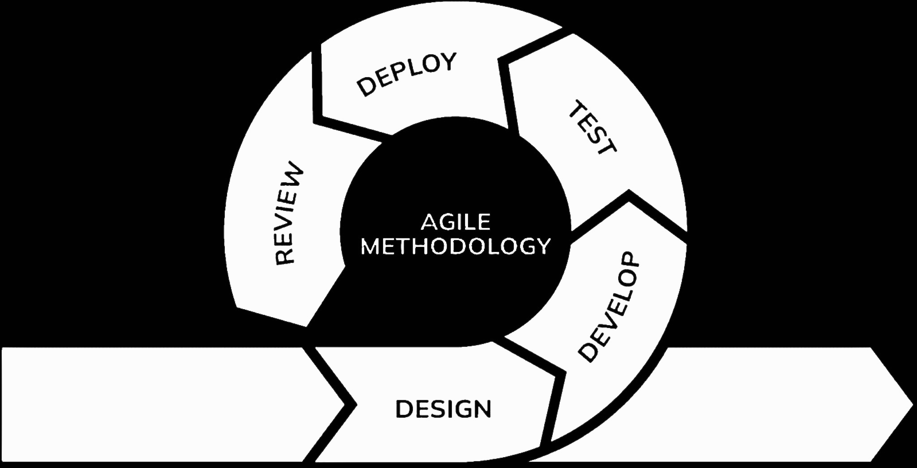

**Figure 1. Agile Development Life Cycle**

**Agile Development Model**

The researchers have chosen the Agile methodology to build their Web-Based Automated Research Approval and Submission System because it offers flexibility, continuous user feedback, and iterative improvement suitable for Eastern Samar State University's dynamic academic environment. This approach follows a cyclical process with six interconnected phases: Requirements, Design, Development, Testing, Deployment, and Review, allowing for regular stakeholder input and rapid adaptation to changing requirements throughout the development process.

By following the iterative phases of the Agile model in continuous cycles, the researchers can deliver working features incrementally and incorporate user feedback continuously. This cyclical approach works well in an academic environment where requirements may evolve based on user needs and institutional changes, as each cycle builds upon the insights gained from the previous iteration.

This method helps the researchers build features iteratively through repeated cycles, developing components like user registration, research title submission, chapter-by-chapter submission process, and panel review interfaces. The Agile model's emphasis on collaboration and flexibility through continuous cycles is appropriate for creating a system that maintains academic standards while improving administrative processes.

**AGILE DEVELOPMENT PHASES**

**Requirements**

In the requirements phase, the research team worked with Eastern Samar State University to identify system needs. The researchers interviewed research administrators to understand the challenges with the current manual approval process. The team documented the features the system needed, created user requirements, and prioritized the most important functions for development. This phase established clear goals for building a web-based research approval system that addressed the university's specific needs.

**Design**

In the design phase, the research team created the system blueprint and user interface designs. The researchers developed wireframes for key pages including login screens, research submission forms, review dashboards, and administrative panels. The team designed a responsive layout using Bootstrap framework to ensure the system worked properly on desktop computers and mobile devices. They also created the database structure and established security measures for different user roles (students, advisers, panel members, administrators).

**Development**

In the development phase, the research team built the Web-Based Automated Research Approval and Submission System. The researchers used HTML for page structure, CSS and Bootstrap for styling, JavaScript for interactive features, PHP for server processing, and MySQL for database management. The team implemented core features including user registration and login, research title submission, chapter-by-chapter upload process, adviser review system, panel evaluation tools, and automated notifications. Each component was tested to ensure proper integration with other system parts.

**Testing**

In the testing phase, the research team carried out comprehensive quality assurance to confirm the system's reliability and functionality. Unit testing was performed on individual components, integration testing on connected features, and system testing on overall performance. User acceptance testing (UAT) was conducted by faculty members and students from the College of Computer Studies at Eastern Samar State University. The UAT participants tested submission interfaces, review processes, and management features to evaluate the system's usability and effectiveness. The researchers documented and addressed any bugs, performance issues, or usability concerns identified during testing.

**Deployment**

In the deployment phase, the research team launched the system at Eastern Samar State University and taught stakeholders how to use it. Faculty, students, and administrators were guided on how to access and navigate the platform, while the team ensured that all automated processes such as data submission, verification, and approval flows worked correctly. The system's performance was monitored by tracking the number of submissions, the speed of verification, and the timeliness of approvals during the initial rollout.

**Review**

In the review phase, the research team gathered feedback from users regarding the completed system. Demonstrations of its key features were conducted, and input on functionality, usability, and overall effectiveness was collected. The team assessed how well the system addressed the university's research approval requirements and documented areas for improvement. This feedback served as the basis for subsequent updates and enhancements to better support students, faculty, and administrators.

**Fishbone Diagram**

**Figure 2. Fishbone Diagram**

The fishbone diagram shows the problem of lack of automated tracking in research management. In the Machine, no notification system to notify users. And no digital system for submission. The Method section points out that the current process is mostly manual processes. For Material, the use of paper forms is an issue. Paper-based take more time, are easy to lose, and can lead to duplicate or missing research files and it use physical space to store them. Lastly, under Management, there's poor tracking of how things are going. Without proper monitoring, it’s hard to know where a submission is in the process or who’s responsible for the next step. The propose solution is a web-based automated research proposal and submission system.

**Gantt chart**

The Gantt Chart helped the researcher plan out their steps in a span of time. The left side represented the list of activities while the top represented the time scale. Each activity was represented by the bar and the length of it represented the start date, duration and the end of the activity.

**Figure Definition.**

|  |  |
| --- | --- |
| **Symbols** | **Descriptions** |
| **Vertical Line** | Represents the series of activities to be done in the system development scheme. |
| **Horizontal Line** | Represents the number of months for the completion of the project. Each month corresponds to the duration of an activity. |
| **Shaded Box** | Represents the amount of months for an activity to be done. It shows the estimated duration of the completion of an activity. This also implies a finished activity. |
| **Unshaded Box** | Represents the amount of months for an activity that has not been done. It shows the estimated duration of the completion of an activity. |
|  |  |

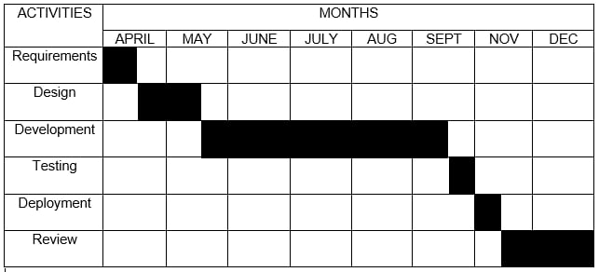

**Table 1. Gantt Chart**

This table shows a Gantt chart that presents the project timeline, outlining the scheduled tasks, activities, and their corresponding durations. It provides a visual representation of the project's phases and progress over a specific period.

**Technical Feasibilities**

**Development**

These specifications define the hardware and software resources required during the creation of the system. They ensure that developers have the necessary tools and computing power to build, test, and refine the project efficiently.

**Table 2. Hardware Specifications (Development)**

Shows the hardware requirement needed in implementation of the project.

|  |  |
| --- | --- |
| **Hardware** | **Specifications** |
| Laptop | **Device name:** Acer Nitro V15  **Processor:** AMD Ryzen 5 6600H with Radeon Graphics 3.30 GHz  **Installed RAM:** 8.00 GB (7.74 GB usable)  **Storage:** 512GB NVMe SSD  **System type:** 64-bit operating system, x64-based processor  **Pen and touch:** No pen or touch input is available for this display |

**Table 3. Software Specifications (Development)**

Shows the software requirement needed in implementation of the project.

|  |  |
| --- | --- |
| **Software** | **System Development Requirements** |
| Integrated Development Environment (IDE) | PHP, HTML, JavaScript, Bootstrap, Visual Studio Code, CSS |
| Web Server | Apache |
| Operating System | Windows 10, Windows 11 |
| Database | MySQL (XAMPP) |

**Implementation**

These specifications outline the minimum hardware and software requirements needed for end-users. They are designed to make the system accessible and functional even on low-end devices commonly available in schools.

**Table 4. Hardware Specifications (Implementation)**

Shows the minimum hardware requirement needed in implementation of the project.

|  |  |  |
| --- | --- | --- |
| **Hardware** | **Specifications** | **Compatibility**  **(Yes or No)** |
| Laptop/Desktop | * **Display:** 14-15.6", FHD/4K, IPS/OLED. * **Processor:** Intel(R) Core (TM) i3-10110U CPU @ 2.10GHz 2.59 GHz * **Memory:** 8.00 GB * **Storage:** 238 GB * **Edition:** Windows 11 Home Single Language. | Yes  Yes  Yes  Yes  Yes |

**Table 5. Software Specifications (Implementation)**

Shows the minimum software requirement needed in implementation of the project.

|  |  |  |
| --- | --- | --- |
| **Software** | **Specifications** | **Compatibility** |
| Browser | Chrome and Microsoft Edge | Yes |

**Figure Definition**

Following were the symbols used in presenting processes in system flowchart. Each Symbol had a corresponding role used in developing and planning the systems flow to understand the system flowchart in developing the symbols with each description.

|  |  |
| --- | --- |
| **Symbols** | **Description** |
|  | **Terminator** - Indicates the beginning or end of a program flow in the diagram |
|  | **Process** - Indicates any processing function. |
|  | **Decision**-Indicates a decision point between two or more paths in a flowchart. |
|  | **Data**-Can represent any type of data in a flowchart may it be an input or output data. |
|  | **Off-page Connector** - An off-page connector is used when the target is on another page. |
|  | **On-page connecter** - are used to replace long lines on a flowchart page. |
|  | **Database** - Represents data housed on a storage service |

**Figure 3. User Authentication Flow**

This flowchart shows how users get inside of Wed-based Automated Research Approval and Submission System. To access the page, the user must first enter their account credentials. The system checks if the inputted credential have a match in the system database if it finds a match, the system check what is the user type the account is, whether it is an student (path A1), panelist (path B1), admin (path C1), or an adviser (path D1) If a user doesn’t have an account, they can sign in to get an account and their information well be saved in the account database.

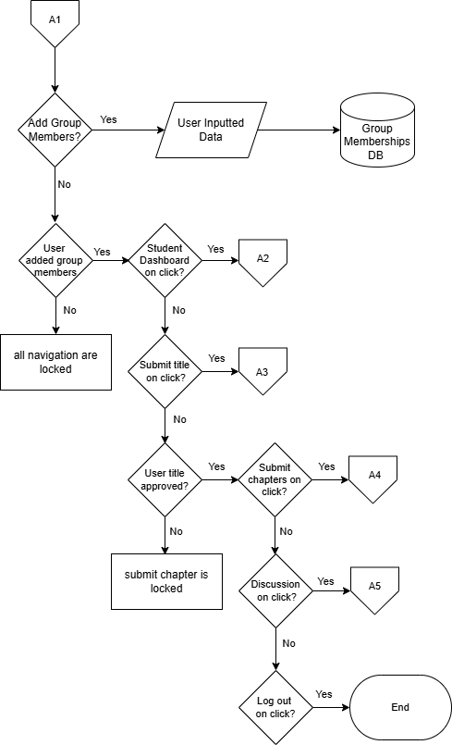

**Figure 4: Student Group**

The flowchart represents when the student first time log in to the system. They are first task to list their group members before they can access the full function of the system. Other functions are locked but can be unlock by finishing the requirements ask of the specific page.

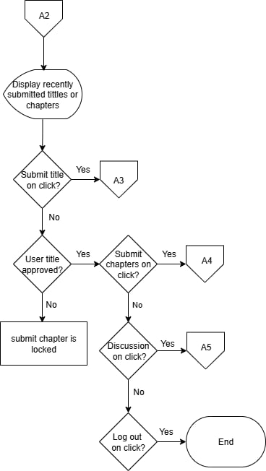

**Figure 5: Student Home**

The flowchart represents the navigation path for a student on the system. Each decision point offers the student a choice to navigate to a specific feature (Submit title, Submit Chapter, Discussion, or Logout). Other functions are locked but can be unlock by finishing the requirements ask of the specific page.

**Figure 6. Research Title Proposal Page**

The flowchart shows the page for students to submit their research titles. Students can choose to submit a new title, view previously submitted titles and check the status of their submissions. If a title is approved, they can proceed to chapter submission. If a title is rejected, they must submit a revised title. Other functions are locked but can be unlock by finishing the requirements ask of the specific page.

**Figure 7. Chapter Submission Page**

The flowchart outlines the navigation path for students within this specific section of the system. Students can choose to submit chapters sequentially (Chapter 1, then Chapter 2, then Chapter 3) after each previous chapter is approved. At each submission, the document is stored in the database. At each decision point, students have the option to select "No," which will return them to the main Chapter Submission page or keep them within the current flow without exiting or logging out.

**Figure 8. Chapter Submission Page Navigation**

This flowchart shows the navigation of Chapter Submission Page the student can access the student home, submit titles, submit for evaluation and log out.

**Figure 9. Discussion Page**

The flowchart shows how students can add their panelist or adviser to their discussion for checking for revision. The chapter will be send to the selected panelist and well send back comments and instructions. Each step, saying "No" keeps them on the same page.

**Figure 10. Panel Member Dashboard Page**

The flowchart outlines the navigation path for panel members within this specific section of the system. Each decision point offers the panelist a choice to navigate to a specific feature. Throughout the process, panel members have the options to log out or exit the dashboard.

**Figure 11. Panel Member Submitted titles Page**

The flowchart shows the submitted titles page. In this page the panelist can view, approve, and reject submitted title proposals. Panelist users have the option to select "No," which keeps them within the current flow without exiting or logging out.

**Figure 12. Panel Member Thesis Discussion**

This flowchart shows the Thesis Discussion Page. This page is where the panelist and student can send messages. In this page the student sends their chapters and the panelist send comments and revision recommendation. Panelist users have the option to select "No," which keeps them within the current flow without exiting or logging out.

**Figure 13. Panel Member Submitted Title (single) Page**

This flowchart shows the Submitted Title Page. This page is where the panelist can review the submitted title and decide to approve or reject it. Panelist users have the option to log out anytime they want.

**Figure14. Panel Member Thesis Discussion Page**

This flowchart shows the Thesis Discussion Page. This page is where the panelist and student can send messages. In this page the student sends their chapters for checking and evaluation then the panelist send comments and revision recommendation. Panelist users have the option to log out anytime they want.

**Figure 15. Admin Dashboard Page**

The flowchart shows the navigation path for Admin within this specific section of the system. Each decision point offers the admin a choice to navigate to a specific feature. Throughout the process, admin members have the options to log out or exit the dashboard.

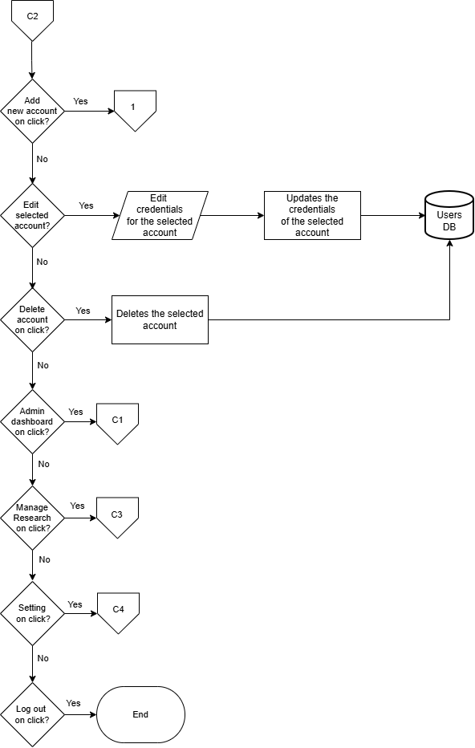

**Figure 16. Manage Users Page**

The flowchart shows the Manage Users page. In this page the Admin can verify or reject student accounts. When a student creates an account in the sign in page. It sends a request to be verify by the admin. If the admin verifies student account this account will be given access to the system. The admin can also create accounts. Throughout the process, the admin has the options to log out or exit the page.

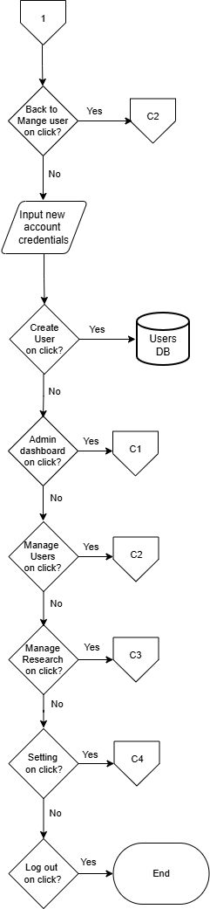

**Figure 17. Register Account Page**

The flowchart shows the Register account page. In this page the Admin can create an account for the panelist. The created account is then save to the database. Throughout the process, the admin has the options to log out or exit the page.

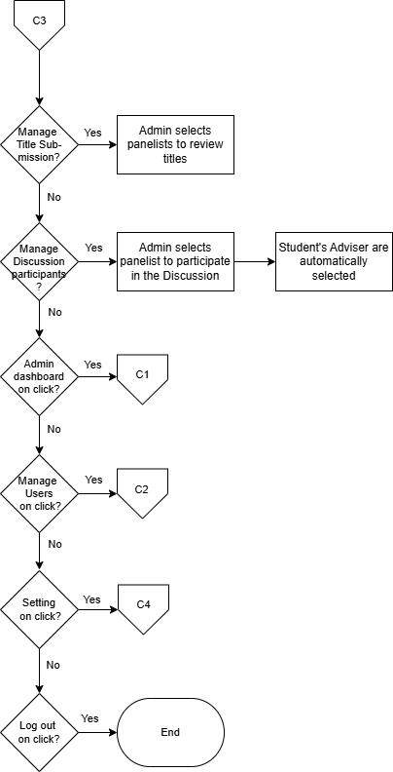

**Figure 18. Manage Research Page**

The flowchart shows the Register account page. In this page the Admin can create an accounts. The created account is then save to the database. Throughout the process, the admin has the options to log out or exit the page.

**Figure 19. Setting Page**

The flowchart shows the Setting page. In this page the admin can adjust the attempt number the user can have before their account is lock and the duration of the time they’re account will be locked. This page enable admin to change password accounts or delete an account. the admin has the options to log out or exit the page.

**Figure 20. Adviser Dashboard Page**

The flowchart outlines the navigation path for Adviser members within this specific section of the system. Each decision point offers the adviser a choice to navigate to a specific feature. Throughout the process, advise members have the options to log out or exit the dashboard.

**Figure 21. Adviser Submitted Titles Page**

The flowchart shows the Advisers submitted titles page. In this page the Adviser can view the list of titles submitted waiting for approval. Adviser users have the option to log out anytime they want.

**Figure 22. Adviser Member Submitted Chapter Page**

The flowchart shows the Advisers submitted chapter page. In this page the Adviser can view the list of chapters submitted by groups of students the Advisers handles waiting for approval. Adviser users have the option to log out anytime they want.

**Figure 23. Adviser Member Thesis Inbox**

This flowchart shows the Thesis Inbox Page. This page is where the Adviser can view all the group chats for thesis discussions and select to open the discussion. Adviser users have the option to log out anytime they want.

**Figure 24. Adviser Member My Group Page**

This flowchart shows the Adviser Member My Group Page. In this page the Adviser can see the list of groups of student he handles. Adviser users have the option to log out anytime they want.

**Figure 25. Adviser Submitted Title (single) Page**

This flowchart shows the Submitted Title Page. This page is where the Adviser can review the submitted title and decide to approve or reject it. Adviser users have the option to log out anytime they want.

**Figure 26. Adviser Submitted Chapter (single) Page**

This flowchart shows the Adviser Member Submitted Chapter page. This is where the Adviser reviews the submitted chapters. When the Adviser is done putting comments and instructions, the Adviser can send the document back to the student. Adviser users have the option to log out anytime they want.

**Figure 27. Adviser Thesis Discussion Page**

This flowchart shows the Thesis Discussion Page. This page is where the Adviser and student can send messages. In this page the student sends their chapters for checking and evaluation then the Adviser send comments and revision recommendation. Adviser users have the option to log out anytime they want.

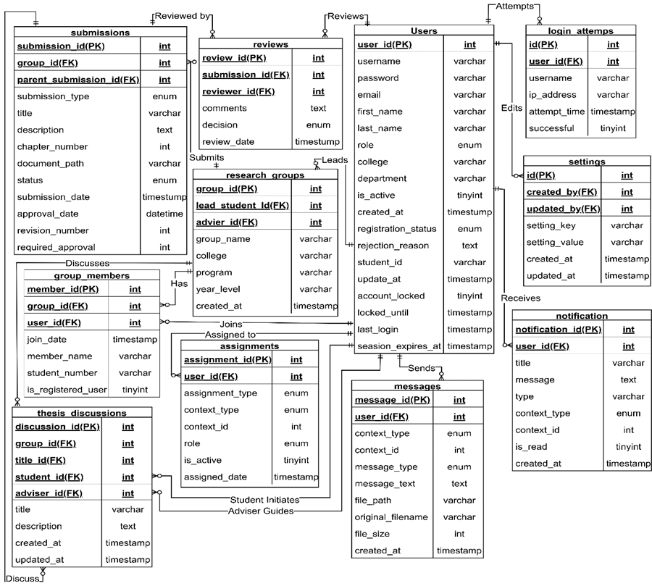**Entity Relationship Diagram**

**Figure 28. Entity Relationship Diagram**

The Entity Relationship Diagram depicts the database structure that supports the Web-Based Automated Research Approval and Submission System. At the center of this system is the Users entity, which connects to all major components. Users can form Research Groups, with each group having designated leaders and panel members. These groups submit Research Titles for approval, which then progress to chapter-by-chapter submissions in the Chapters entity. Faculty members provide feedback through the Reviews entity, which connects to both research titles and individual chapters. Groupmembership is tracked through the Group Members entity, ensuring proper attribution and collaboration. The system keeps users informed through the Notifications entity, which delivers messages about submission status, review feedback, and approval decisions. This interconnected structure enables seamless tracking of research proposals

from initial submission through final approval, while maintaining appropriate relationships between students, faculty, and their respective contributions to the research process.

**Data Dictionary**

Data dictionaries provide a precise vocabulary for specific data elements, helping to standardize a data set and ensure that the relevance and quality of data elements are consistent for all users. They describe the meaning and purpose of data elements within the context of a project and offer guidance on their interpretation.

**Table 6: users**

|  |  |  |  |  |
| --- | --- | --- | --- | --- |
| **Field Name** | **Data Type** | **Size** | **Attributes** | **Description** |
| user_id | int | 11 | PK | Unique identifier for users |
| username | varchar | 30 | UK | Login username of user |
| password | varchar | 255 |  | Encrypted login password |
| Email | varchar | 100 | UK | User's email address |
| first_name | varchar | 30 |  | User's first name |
| last_name | varchar | 30 |  | User's last name |
| Role | enum |  |  | User role (student, adviser, panel, admin) |
| college | varchar | 80 |  | User's college affiliation |
| department | varchar | 80 |  | User's department affiliation |
| is_active | tinyint | 1 |  | Account status (1=active, 0=inactive) |
| created_at | timestamp |  |  | User creation timestamp |
| registration_status | enum |  |  | Registration status (pending, approved, rejected) |
| rejection_reason | text |  |  | Reason for account rejection |
| student_id | varchar | 15 |  | Student ID number |
| updated_at | timestamp |  |  | Last update timestamp |
| account_locked | tinyint | 1 |  | Account lock status (1=locked, 0=unlocked) |
| locked_until | timestamp |  |  | Account unlock timestamp |
| last_login | timestamp |  |  | Last successful login timestamp |
| session_expires_at | timestamp |  |  | Session expiration timestamp |

**Table 7: research_groups**

|  |  |  |  |  |
| --- | --- | --- | --- | --- |
| **Field Name** | **Data Type** | **Size** | **Attributes** | **Description** |
| group_id | Int | 11 | PK | Unique identifier for research groups |
| group_name | Varchar | 80 |  | Name of the research group |
| lead_student_id | Int | 11 | FK | ID of the group leader |
| adviser_id | Int | 11 | FK | ID of the assigned adviser |
| college | Varchar | 80 |  | College affiliation |
| program | Varchar | 50 |  | Academic program |
| year_level | Varchar | 15 |  | Year level of the group |
| created_at | Timestamp |  |  | Group creation timestamp |

**Table 8: group_memberships**

|  |  |  |  |  |
| --- | --- | --- | --- | --- |
| **Field Name** | **Data Type** | **Size** | **Attributes** | **Description** |
| membership_id | Int | 11 | PK | Unique identifier for each membership |
| group_id | Int | 11 | FK | ID of the research group |
| user_id | Int | 11 | FK | ID of registered user member |
| member_name | Varchar | 100 |  | Name of non-registered member |
| student_number | Varchar | 15 |  | Student number of member |
| is_registered_user | Tinyint | 1 |  | Whether member is a registered user |
| join_date | Timestamp |  |  | Date member joined the group |

**Table 9: submissions**

|  |  |  |  |  |
| --- | --- | --- | --- | --- |
| **Field Name** | **Data Type** | **Size** | **Attributes** | **Description** |
| submission_id | Int | 11 | PK | Unique identifier for each submission |
| group_id | Int | 11 | FK | ID of the submitting group |
| submission_type | Varchar | 20 |  | Type: title, chapter |
| Title | Varchar | 200 |  | Title of the submission |
| description | Text |  |  | Detailed description of submission |
| chapter_number | Int | 11 |  | Chapter number (for chapter submissions) |
| document_path | Varchar | 255 |  | Path to uploaded document file |
| status | Varchar | 20 |  | Status: pending, approved, rejected |
| submission_date | Timestamp |  |  | Date of submission |
| approval_date | Datetime |  |  | Date when submission was approved |
| revision_number | Int | 11 |  | Revision number of the submission |
| parent_submission_id | Int | 11 | FK | ID of parent submission (for revisions) |
| required_approvals | Int | 11 |  | Number of required approvals |

**Table 10: reviews**

|  |  |  |  |  |
| --- | --- | --- | --- | --- |
| **Field Name** | **Data Type** | **Size** | **Attributes** | **Description** |
| review_id | Int | 11 | PK | Unique identifier for each review |
| submission_id | Int | 11 | FK | ID of reviewed submission |
| reviewer_id | Int | 11 | FK | ID of the reviewer |
| comments | Text |  |  | Reviewer's comments |
| decision | Varchar | 20 |  | Decision: approve, reject, needs_revision |
| review_date | Timestamp |  |  | Date of review |

**Table 11: assignments**

| **Field Name** | **Data Type** | **Size** | **Attributes** | **Description** |
| --- | --- | --- | --- | --- |
| assignment_id | Int | 11 | PK | Unique identifier for each assignment |
| assignment_type | Varchar | 20 |  | Type: reviewer, participant |
| context_type | Varchar | 20 |  | Context: submission, discussion |
| context_id | Int | 11 |  | ID of the context (submission or discussion) |
| user_id | Int | 11 | FK | ID of assigned user |
| Role | Varchar | 20 |  | Role: student, adviser, panel |
| is_active | Tinyint | 1 |  | Assignment active status |
| assigned_date | Timestamp |  |  | Date of assignment |

**Table 12: thesis_discussions**

|  |  |  |  |  |
| --- | --- | --- | --- | --- |
| **Field Name** | **Data Type** | **Size** | **Attributes** | **Description** |
| discussion_id | Int | 11 | PK | Unique identifier for each discussion |
| group_id | Int | 11 | FK | ID of the research group |
| title_id | Int | 11 | FK | ID of related title submission |
| student_id | Int | 11 | FK | ID of student initiating discussion |
| adviser_id | Int | 11 | FK | ID of assigned adviser |
| Title | Varchar | 200 |  | Discussion title |
| description | Text |  |  | Discussion description |
| created_at | Timestamp |  |  | Discussion creation timestamp |
| updated_at | Timestamp |  |  | Last update timestamp |

**Table 13: messages**

| **Field Name** | **Data Type** | **Size** | **Attributes** | **Description** |
| --- | --- | --- | --- | --- |
| message_id | Int | 11 | PK | Unique identifier for each message |
| context_type | Varchar | 20 |  | Context: submission, discussion, general |
| context_id | Int | 11 |  | ID of the context |
| user_id | Int | 11 | FK | ID of message sender |
| message_type | Varchar | 20 |  | Type: text, file, system |
| message_text | Text |  |  | Message content |
| file_path | Varchar | 255 |  | Path to attached file |
| original_filename | Varchar | 100 |  | Original name of attached file |
| file_size | Int | 11 |  | Size of attached file in bytes |
| created_at | Timestamp |  |  | Message creation timestamp |

**Table 14: notifications**

| **Field Name** | **Data Type** | **Size** | **Attributes** | **Description** |
| --- | --- | --- | --- | --- |
| notification_id | Int | 11 | PK | Unique identifier for each notification |
| user_id | Int | 11 | FK | ID of recipient user |
| Title | Varchar | 80 |  | Notification title |
| message | Text |  |  | Notification message content |
| Type | Varchar | 30 |  | Type of notification |
| context_type | Varchar | 20 |  | Context: submission, discussion, group, system |
| context_id | Int | 11 |  | ID of related context |
| is_read | Tinyint | 1 |  | Read status (1=read, 0=unread) |
| created_at | Timestamp |  |  | Notification creation timestamp |

**Table 15: login_attempts**

|  |  |  |  |  |
| --- | --- | --- | --- | --- |
| **Field Name** | **Data Type** | **Size** | **Attributes** | **Description** |
| Id | Int | 11 | PK | Unique identifier for each login attempt |
| username | Varchar | 30 |  | Username used in login attempt |
| ip_address | Varchar | 45 |  | IP address of login attempt |
| attempt_time | Timestamp |  |  | Timestamp of login attempt |
| successful | Tinyint | 1 |  | Success status (1=successful, 0=failed) |
| user_id | Int | 11 | FK | ID of user (if successful login) |

**Table 16: settings**

|  |  |  |  |  |
| --- | --- | --- | --- | --- |
| **Field Name** | **Data Type** | **Size** | **Attributes** | **Description** |
| Id | Int | 11 | PK | Unique identifier for each setting |
| setting_key | Varchar | 100 |  | Setting key/name |
| setting_value | Text |  |  | Setting value |
| created_at | Timestamp |  |  | Setting creation timestamp |
| updated_at | Timestamp |  |  | Last update timestamp |
| created_by | Int | 11 | FK | ID of user who created setting |
| updated_by | Int | 11 | FK | ID of user who last updated setting |

**System Architecture**

**Figure 29. System Architecture**

The figure shows the system architecture of the Web-Based Automated Research Approval and Submission System, using a client-server model connected through the internet. On the server side, administrators operate the backend system with dedicated hardware. They manage user accounts, and research submissions. On the client side, users (students, and panelist) access the system through their devices. They submit research proposals, review chapters, and check approval status. The server and clients exchange data over the internet for submissions, reviews, and notifications.

**Output and User Interface**

This is the process of designing user interface of the project. It serves as a blueprint on how the project's user interface will look like. Below are the figures showing the key interfaces.

**Figure 30. Login Page**

Shows the login page for all users. It's a simple screen with just two boxes - one for email and one for password. Users can also select "Sign Up" if they need to create a new account. The page includes the university logo and system name to establish institutional identity.

**Figure 31. Research Title Submission Page**

Shows the page where students submit their research titles for approval. The interface contains a form with four elements: a field to enter the proposed research title, a section for group members, a document attachment button for uploading the title proposal in .docx format, and a submit button.

**Figure 32. Chapter Submission Page**

Shows the page where students upload their research chapters. The interface includes chapter selection options, file upload functionality, and submission controls. Students cannot submit the other steps if the adviser need revision, it will only if its complete or does not require revision.

**Figure 33. Panel/Adviser Dashboard**

Shows the page where advisers can view counts of submitted research titles, chapters, and completed versions in their evaluation inbox. The interface displays numerical indicators showing how many submissions from students are pending review in each category.

**Figure 34. Chapter Review Page**

Shows the page where advisers can see the students' submitted chapters in sequential order. The interface displays the chapters sent by students for review. Advisers can return files to students if revisions are needed or approve them to allow students to proceed to the next chapter submission.

**Figure 35. Admin Dashboard**

Shows the administrative dashboard for the research approval system. The interface displays statistics about system usage at the top. Below are sections for managing users, monitoring submission activity, and accessing system settings.

**Data Flow Diagram**

Data flow diagrams show the way information flows through a process or system. They include data inputs and outputs, data stores, and the various sub-processes the data moves through. DFDs are built using standardized symbols and notation to describe various entities and their relationships.

**Figure Definition**

These are the common symbols that were use to present the specific that the actors had taken in using the entire project. This was presented through a Data Flow Diagram.

**Symbols**

**Description**

Source (Sink)

Process

The source of System inputs or sink of system outputs

Step-by-step instructions are followed that transform inputs (a computer or a person or t=both doing the work)

Data Store

An open-ended rectangle represents the location where data is stored

Data Flow Symbol

Represent a pathway for data

**Figure 36. Context Diagram (Level 0)**

Shows the Web-Based Automated Research Approval and Submission System as a single process interacting with four external entities: Students, Advisers, Panel members, and Administrators. Students submit registration data, research titles, and chapters, receiving approval notifications and review comments. Advisers review submissions and provide feedback. Panel members evaluate complete submissions after oral defense. Administrators verify accounts and manage system settings. The diagram illustrates data flows between external entities and the system without showing internal processes.

**Figure 37. Level 1 Data Flow Diagram**

The Level 1 DFD shows ten main processes within the system. Students register through Process 1.0 (User Registration), storing data in D1 (users). Administrators verify accounts via Process 2.1 (Create Account) and manage users through Process 2.0 (Manage Accounts), with settings in D7. Process 3.0 (Create Group) stores group data in D2 and D3. Students submit titles through Process 4.0 (Submit Title) and chapters through Process 7.0 (Submit Chapter), both stored in D4 (Submissions). Process 5.0 (Review Title) and 8.0 (Review Chapter) handle evaluations, storing reviews in D5. Process 6.0 (Approve/Reject Title) and 9.0 (Approve/Revise Chapter) manage decisions and assignments in D6. Process 10.0 (Thesis Discussion) facilitates communication between all users.

**Programming Environment**

**HTML (Hypertext Markup Language) -** HTML forms the structural foundation of our Web-Based Automated Research Approval and Submission System. It builds elements like login boxes, submission forms, review interfaces, and dashboards. We use HTML to place components in appropriate locations. It serves as the foundation for other features like styling and interaction.

**CSS (Cascading Style Sheets) -** CSS adds visual elements to our Web-Based Automated Research Approval and Submission System. It applies the university's colors, formats text, and maintains consistent styling. We use Bootstrap framework to make the system display correctly on both desktop computers and mobile devices. This allows students and faculty to access the system from different devices.

**Bootstrap -** Bootstrap serves as the foundational CSS framework for our Web-Based Automated Research Approval and Submission System, providing the essential building blocks for creating a professional, responsive user interface. In our system, Bootstrap handles the visual presentation layer by supplying pre-built components such as navigation bars, forms, cards, buttons, and responsive grid layouts that ensure consistent styling across all modules from student dashboards to admin panels. Its mobile-first responsive design automatically adapts our interface to work seamlessly on desktop computers, tablets, and smartphones, making the system accessible to users regardless of their device.

**JavaScript** - JavaScript adds interactivity to our Web-Based Automated Research Approval and Submission System. It checks form inputs before submission, gives immediate responses, and updates content without reloading pages. When advisers review chapters, JavaScript shows the document and feedback form on the same screen. It also runs the notification system that informs users about new submissions or status changes.

**PHP (Hypertext Preprocessor)** - PHP handles the background processes in our Web-Based Automated Research Approval and Submission System. It processes form submissions, manages user login, and controls database operations. When students upload a chapter or advisers give feedback, PHP processes these actions and updates the database. It also creates pages based on user roles, so each user sees only their relevant information.

**MySQL -** MySQL stores all Web-Based Automated Research Approval and Submission System information. It contains tables for users, research groups, titles, chapters, reviews, and notifications. The database connects related information through table relationships, like connecting student accounts to research groups and submissions. MySQL handles the different types of data needed in the research approval process.

**Evaluation**

The respondents evaluated the system using the following scale:

|  |  |
| --- | --- |
| **Level of Agreement** | **Scale Description** |
| 5 | Strongly Agree |
| 4 | Agree |
| 3 | Fair |
| 2 | Disagree |
| 1 | Strongly Disagree |

**System Testing (Alpha Testing)**

The obtained mean was interpreted using the following:

**Functional Suitability**

|  |  |
| --- | --- |
| **Numerical Equivalent** | **Interpretation** |
| 4.20 – 5.00 | Highly Functional |
| 3.40 – 4.19 | Functional |
| 2.60 – 3.39 | Moderately Functional |
| 1.80 – 2.59 | Slightly Functional |
| 1.00 – 1.79 | Poorly Functional |

**Performance Efficiency**

|  |  |
| --- | --- |
| **Numerical Equivalent** | **Interpretation** |
| 4.20 – 5.00 | Highly Efficient |
| 3.40 – 4.19 | Efficient |
| 2.60 – 3.39 | Moderately Efficient |
| 1.80 – 2.59 | Slightly Efficient |
| 1.00 – 1.79 | Inefficient |

**Compatibility**

|  |  |
| --- | --- |
| **Numerical Equivalent** | **Interpretation** |
| 4.20 – 5.00 | Highly Compatible |
| 3.40 – 4.19 | Compatible |
| 2.60 – 3.39 | Moderately Compatible |
| 1.80 – 2.59 | Slightly Compatible |
| 1.00 – 1.79 | Incompatible |

**Reliability**

|  |  |
| --- | --- |
| **Numerical Equivalent** | **Interpretation** |
| 4.20 – 5.00 | Highly Reliable |
| 3.40 – 4.19 | Reliable |
| 2.60 – 3.39 | Moderately Reliable |
| 1.80 – 2.59 | Slightly Reliable |
| 1.00 – 1.79 | Unreliable |

**Security**

|  |  |
| --- | --- |
| **Numerical Equivalent** | **Interpretation** |
| 4.20 – 5.00 | Highly Secured |
| 3.40 – 4.19 | Secured |
| 2.60 – 3.39 | Moderately Secured |
| 1.80 – 2.59 | Slightly Secured |
| 1.00 – 1.79 | Unsecured |

**Acceptance testing (Beta testing)**

The obtained mean was interpreted using the following:

|  |  |
| --- | --- |
| **Numerical Equivalent** | **Interpretation** |
| 4.20 – 5.00 | Highly Acceptable |
| 3.40 – 4.19 | Acceptable |
| 2.60 – 3.39 | Moderately Acceptable |
| 1.80 – 2.59 | Slightly Acceptable |
| 1.00 – 1.79 | Unacceptable |

**<**

**Research Design**

The study used the developmental-evaluation research design approach as the system was subjected to end user evaluation. This approach combines the development of the Web-Based Automated Research Approval and Submission System with a systematic evaluation of its effectiveness and usability.

**Research Locale**

The study was conducted at Eastern Samar State University, focusing primarily on the research processes across its various colleges and departments. The university is located in Borongan City, Eastern Samar, Philippines.

**Figure 39. Research Locale**

**Research Respondents**

The study involved two groups of respondents: twenty (20) end users, and seven (7) CCS faculty members.

|  |  |
| --- | --- |
| **RESPONDENTS** | **NUMBERS OF RESPONDENTS** |
| End User | 20 |
| CCS Faculty Members | 7 |

**Table 17. Distribution of Respondents**

**Instrumentation**

In this phase, the evaluation of the system was conducted using two instruments: the ISO/IEC 25010:2011 Software Evaluation Questionnaire and the IBM Computer Usability Satisfaction Questionnaire. The ISO/IEC 25010:2011 instrument was utilized during system testing to assess quality metrics, including functional suitability, performance efficiency, compatibility, reliability, usability, and security. The IBM Computer Usability Satisfaction Questionnaire was employed during acceptance testing to evaluate user experience dimensions such as ease of use, system simplicity, task completion effectiveness, error recovery, interface organization, and overall satisfaction. By employing these standardized evaluation frameworks, the study aimed to obtain comprehensive and reliable insights into both the operational quality and user acceptance of the system, ensuring it met the prescribed standards and effectively addressed stakeholder needs and expectations.

**Data Analysis**

Statistics using the mean was employed to present the demographic characteristics of the respondents and the level of the system effectiveness. The data from the ISO/IEC 25010:2011 Software Evaluation Questionnaire and IBM Computer Usability Satisfaction Questionnaire will be analyzed to assess the system's quality and usability during the alpha test, and the selected respondents during the beta test

**Mean**

This is the average of the score -- the mathematical center of a distribution. It used symmetrical, unimodal distributions of interval or ratio scores.

The ISO's formula mean is:

X = Σ *x/n*

Where:

* Σx = sum of all scores
* *n* = number of scores

The IBM formula mean is:

SUS = (Q1 + Q2 + Q3 + ... + Q10) ÷ 10

Where:

* Q1-10: Scores for each question

**Chapter IV**

**RESULTS AND DISCUSSIONS**

This chapter presents the results of the Web-Based Automated Research Approval and Submission System developed for Eastern Samar State University. The discussion covers the system implementation results, screenshots of the system interfaces, and feedback obtained from stakeholders who tested the system using the ISO/IEC 25010:2011 questionnaire for alpha testing and the IBM Computer Usability Satisfaction Scale for beta testing.

**System Implementation Results**

The Web-Based Automated Research Approval and Submission System was successfully developed and deployed at Eastern Samar State University. The system provides comprehensive functionality for managing research proposal workflows from initial title submission through final panel evaluation. The implementation includes distinct user interfaces for students, faculty advisers, panel members, and administrators, each designed with role-specific features to support efficient research management processes.

**Screenshots of the Developed System**

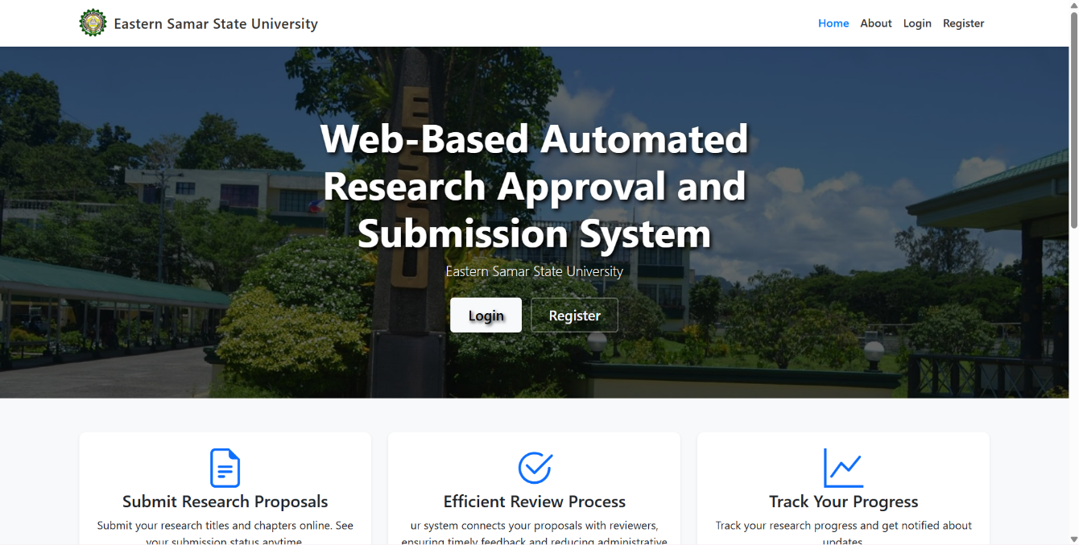

**Figure 40. Login page**

This is the entry point for users. It requires a username and password to access the system. New users can sign up using the 'Sign Up' link, and there's a 'Back to Home' link to return to the main landing page.

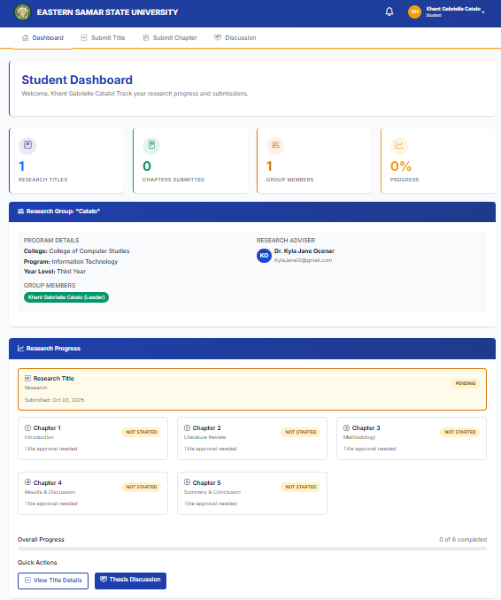

**Figure 41. Student Dashboard**

This dashboard is for students. It shows a student's progress and submissions. Key information displayed includes the number of research titles submitted, the number of chapters submitted, the number of group members and the overall progress of their research.

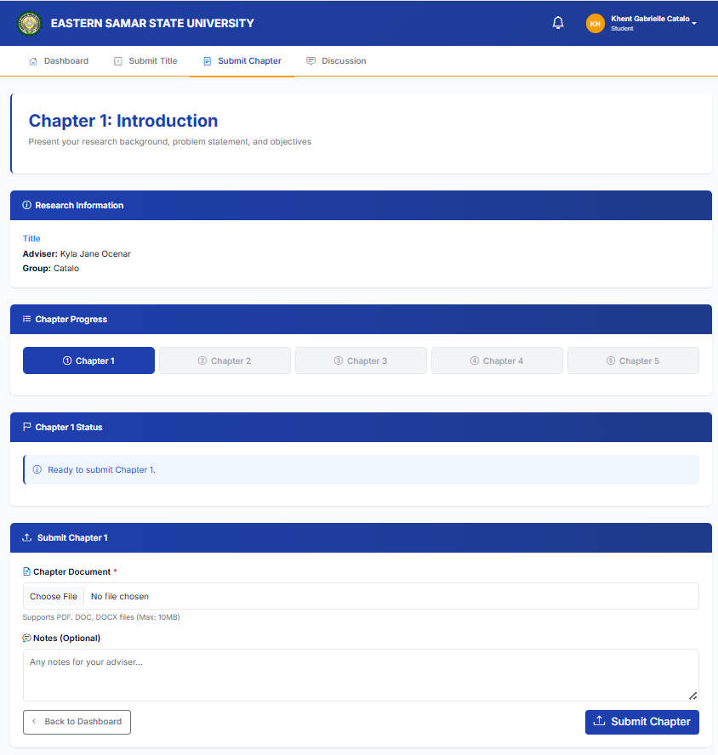

**Figure 42. Chapter Submission**

This interface shows the student’s view of their step-by-step chapter submission process (Chapters 1-5) with adviser approval requirements.

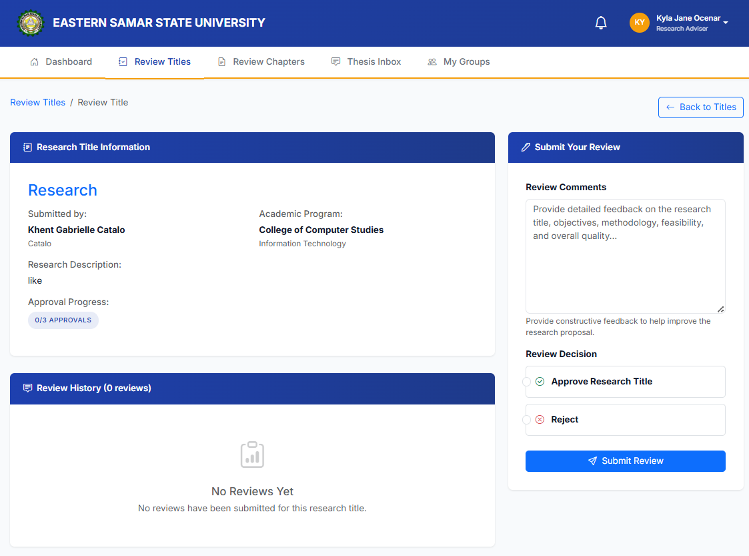

**Figure 43. Title Reviewing**

This interface displays the Title Review page, which shows the status of approved chapters. It also allows the reviewers to approve or reject title and provide comments.

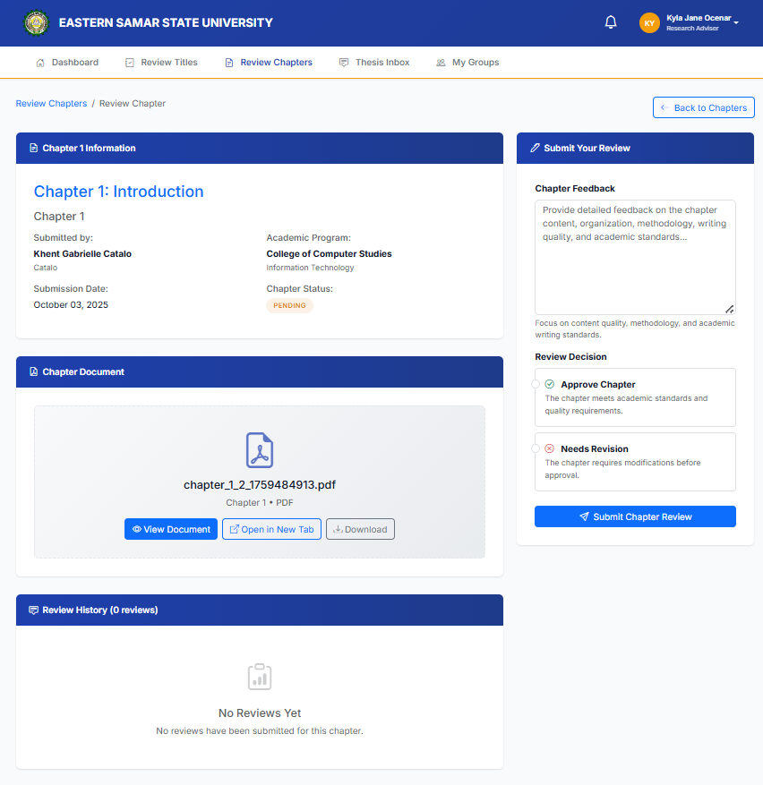

**Figure 44. Chapter Reviewing**

This interface displays the Chapter Review page, which shows the status of approved chapters. It also allows the adviser to approve or reject submissions for revision and to provide comments.

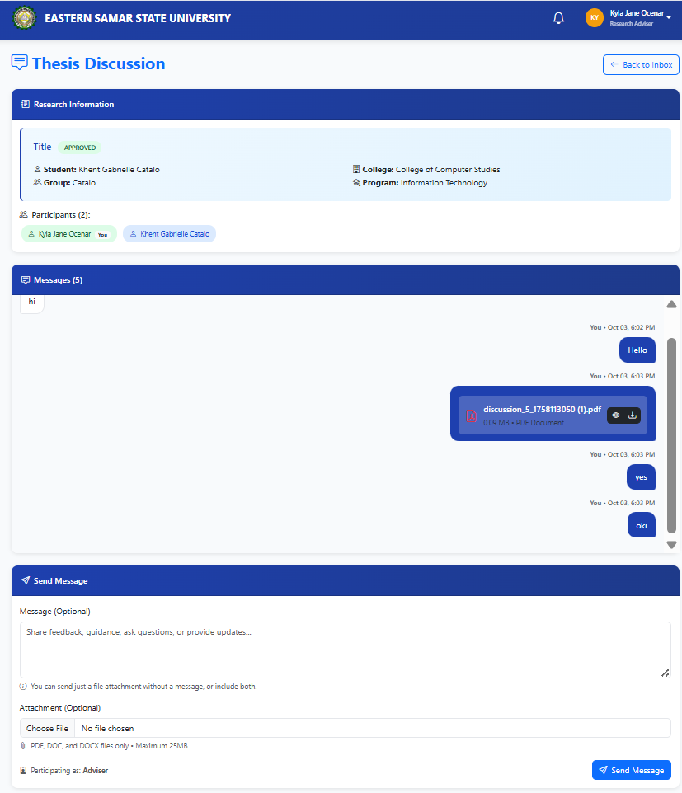

**Figure 45. Messaging form**

The thesis discussion page facilitates communication between the researcher, advisers and panel members. The messaging system enables real-time collaboration and feedback exchange throughout the research process.

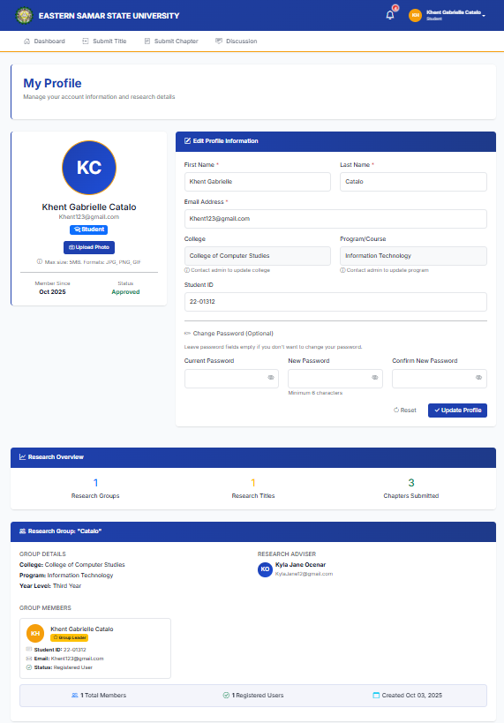

**Figure 46. Profile**

The student profile page allows users to manage their personal information and research details. The interface includes com profile editing functionality.

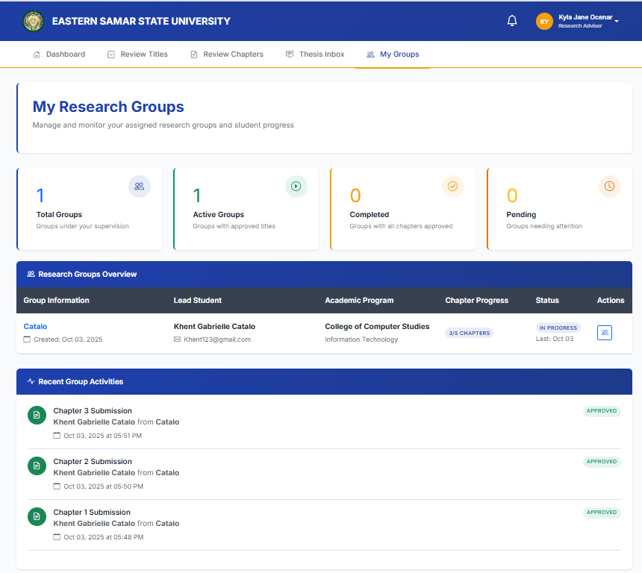

**Figure 47. Adviser Research Group Management**

Research advisers log in and navigate to "My Groups" to view their assigned research groups. The dashboard shows summary statistics of group statuses. Advisers can click on a specific group to see detailed progress, including chapter completion rates and student information. The Recent Group Activities section displays a timeline of student submissions, showing which chapters have been submitted and their approval status. Advisers can click the action button to view full group details and manage submissions.

**Figure 48. Admin Dashboard**

Admins log in and immediately see what matters most. Quick stats at the top show how many users and research groups are active, the middle section flags anything waiting for their attention like pending reviews or new user signups, and a live feed at the bottom keeps them in the loop on what's happening across the platform.

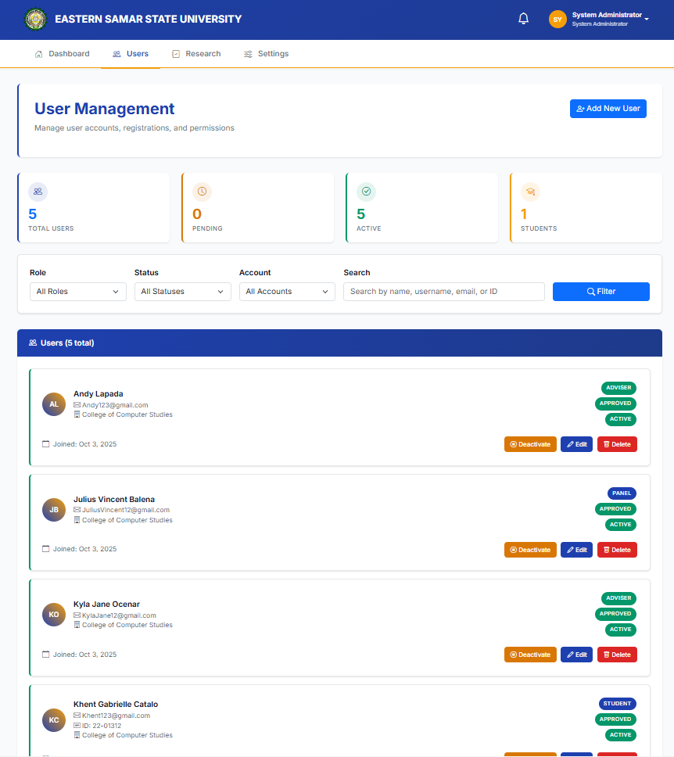

**Figure 49. User Management**

Administrators access the Users section to manage all accounts. They can filter users by role, status, or account type using dropdown menus, or search for specific users. The system displays a complete list of users with their details and current status badges. Administrators can perform actions on individual users: deactivate accounts, edit user information, or delete users entirely. The "Add New User" button allows creation of new accounts.

**Figure 50. Research Records**

Users navigate to the Research section to view all research submissions. The system displays aggregate statistics at the top showing the total count of titles, chapters, and their approval statuses. Users can toggle between "Research Groups" and "All Submissions" tabs. Selecting a research group reveals detailed information including the group leader, adviser, and progress metrics. The "Manage Submissions" button allows admins to assign reviewers for research titles, while the "Manage Discussion" button enables users to add or manage participants in discussion threads.

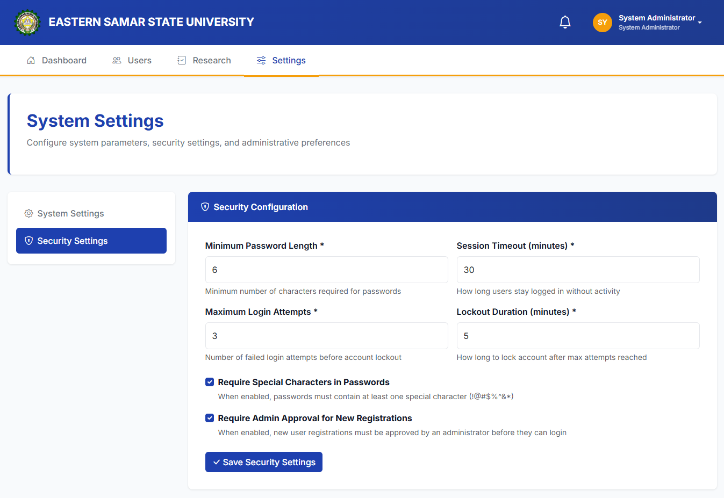

**Figure 51. System Settings**

Admins head to the Settings section and click on "Security Configuration" from the sidebar. Here, they can set up important security rules like minimum password length, how many login attempts are allowed before an account gets locked, and how long users can stay logged in before being automatically signed out. They can also toggle options to require special characters in passwords or make new user registrations need admin approval before accounts go live. Once everything looks good, they hit "Save Security Settings" to apply the changes across the system.

**Alpha Testing Results (ISO/IEC 25010:2011)**

Alpha testing was conducted with IT professionals and system developers to evaluate the technical quality of the system. The results are presented below:

**Table 18. Functional Suitability Results**

|  |  |  |
| --- | --- | --- |
| **System Description** | **Weighted Mean** | **Interpretation** |
| 1. Functional Completeness. The system covers all the specified tasks and user objectives. | 4,7 | Highly Functional |
| 1. Functional Correctness. The system provides the correct results with the needed degree of precision. | 4.7 | Highly Functional |
| 1. Functional Appropriateness. The system facilitates the accomplishment of specified tasks and objectives. | 4.7 | Highly Functional |
| **Grand Mean** | **4.7** | **Highly Functional** |

The result in table 12 shows that the system gained a weighted grand mean of 4.7 interpreted as Highly functional. The result implies that the system adhered to the ISO standards in terms of Performance Suitability.

**Table 19. Performance Efficiency Results**

|  |  |  |
| --- | --- | --- |
| **System Description** | **Weighted Mean** | **Interpretation** |
| 1. Time Behavior. The system’s response and processing times and throughput rates when performing its functions, meet requirements. | 4.5 | Highly Efficient |
| 1. Resource Utilization. The system’s amounts and types of resources used when performing its functions, meet requirements. | 4.5 | Highly Efficient |
| 1. Capacity. The system’s maximum limits of parameter meet requirements. | 4.4 | Highly Efficient |
| **Grand Mean** | **4.4** | **Highly Efficient** |

The result in table 13 shows that the system gained a weighted grand mean of 4.4 interpreted as Highly efficient. The result implies that the system adhered to the ISO standards in terms of Performance Efficiency.

**Table 20. Compatibility Results**

|  |  |  |
| --- | --- | --- |
| **System Description** | **Weighted Mean** | **Interpretation** |
| 1. Co-existence. The system can perform its required functions efficiently while sharing a common environment and resources with other products, without detrimental impact on any other product. | 4.4 | Highly Compatible |
| 1. Interoperability. The system can exchange information and use the information that has been exchanged. | 4.5 | Highly Compatible |
| **Grand Mean** | **4.4** | **Highly Compatible** |

The result in table 14 shows that the system gained a weighted grand mean of 4.4 interpreted as Highly compatible. The result implies that the system adhered to the ISO standards in terms of Compatibility.

**Table 21. Reliability Results**

|  |  |  |
| --- | --- | --- |
| **System Description** | **Weighted Mean** | **Interpretation** |
| 1. Maturity. The system meets the needs for reliability under normal operation | 4.5 | Highly Reliable |
| 1. Availability. The system is operational and accessible when required for use. | 4.5 | Highly Reliable |
| 1. Fault Tolerance. The system operates as intended despite the presence of hardware or software faults. | 4.5 | Highly Reliable |
| 1. Recoverability. The system can recover the data directly affected and re-establish the desired state. | 4.5 | Highly Reliable |
| **Grand Mean** | **4.5** | **Highly Reliable** |

The result in table 15 shows that the system gained a weighted grand mean of 4.5 interpreted as Highly reliable. The result implies that the system adhered to the ISO standards in terms of Reliability.

**Table 22. Security Results**

|  |  |  |
| --- | --- | --- |
| **System Description** | **Weighted Mean** | **Interpretation** |
| 1. Confidentiality. The system ensures that data are accessible only to those authorized to have access. | 4.4 | Highly Secured |
| 1. Integrity. The system prevents unauthorized access to, or modification of, computer programs or data. | 4.5 | Highly Secured |
| 1. Non-repudiation. The system can be proven to have taken place, so that the events or actions cannot be repudiated later. | 4.7 | Highly Secured |
| **Grand Mean** | **4.5** | **Highly Secured** |

The result in table 16 shows that the system gained a weighted grand mean of 4.8 interpreted as Highly secured. The result implies that the system adhered to the ISO standards in terms of Security.

**Table 23. Overall Alpha Testing Summary**

|  |  |  |
| --- | --- | --- |
| **Quality Characteristic** | **Mean Score** | **Interpretation** |
| Functional Suitability | 4.7 | Highly Functional |
| Performance Efficiency | 4.4 | Highly Efficient |
| Compatibility | 4.4 | Highly Compatible |
| Reliability | 4.5 | Highly Reliable |
| Security | 4.5 | Highly Secured |
| **Grand Mean** | **4.5** | **Highly Acceptable** |

The overall alpha testing results demonstrate that the Web-Based Automated Research Approval and Submission System achieved consistently high ratings across all five quality characteristics measured by the ISO/IEC 25010:2011 standard. The grand mean of 4.5 falls within the 4.20-5.00 range, which according to the evaluation scale is interpreted as "Highly Acceptable."

**Beta Testing (End Users Testing)**

The table below represents the results of the conducted testing and survey using the questionnaire adopted from IBM Software evaluation questionnaire.

**Table 24. IBM Computer System Usability for Quality Metrics Evaluation Result**

|  |  |  |
| --- | --- | --- |
| **System Description** | **Weight Mean** | **Interpretation** |
| 1. Overall, I am satisfied with how easy it is to use this system. | 4.6 | Highly Acceptable |
| 1. It was simple to use this system. | 4.65 | Highly Acceptable |
| 1. I can effectively complete the tasks using this system. | 4.6 | Highly Acceptable |
| 1. I am able to complete my work quickly using this system. | 4.6 | Highly Acceptable |
| 1. I feel comfortable using this system. | 4.3 | Highly Acceptable |
| 1. It was easy to learn to use this system. | 4.7 | Highly Acceptable |
| 1. Whenever I make a mistake using the system, I recover easily and quickly. | 4.4 | Highly Acceptable |
| 1. The organization of information on the system screens is clear. | 4.45 | Highly Acceptable |
| 1. The interface of this system is pleasant. | 4.2 | Highly Acceptable |
| 1. I like using the interface of this system. | 4.35 | Highly Acceptable |
| 1. Overall, I am satisfied with this system. | 4.6 | Highly Acceptable |
| **Grand Mean** | **4.49** | **Highly Acceptable** |

The result in table 13 shows that the system gained a weighted grand mean of 4.49 interpreted as Highly acceptable during the beta testing. The result implies that the system has adhered to the survey’s target standards.

**Interpretation: Highly Acceptable**

The beta testing results show that users find the system highly acceptable and easy to use. The high scores across all categories indicate that the system meets user expectations and provides a positive experience for road hazard reporting and navigation.

**Chapter V**

**CONCLUSION AND RECOMMENDATION**

The researcher came to the following conclusions after analyzing the data developed Web-Based Automated Research Approval and Submission System for Eastern Samar State University. The study accomplished the following goals:

1. **Developed a comprehensive research management system** that successfully addresses the manual tracking and monitoring challenges at Eastern Samar State University. The system provides students, faculty, and administrators with a centralized platform for managing research proposals from submission to approval.
2. **Implemented user registration and verification features** that allow students to create accounts with their group information and academic details, while administrators can verify and manage these accounts effectively.
3. **Created a sequential research workflow** that enables students to submit titles for approval, followed by chapter-by-chapter submissions that require adviser approval before proceeding to the next stage.
4. **Integrated notification mechanisms** that keep all users informed about submission status changes, new comments, and pending reviews.
5. **Evaluated the system using standardized testing methods** with positive results. The ISO/IEC 25010:2011 software evaluation showed high ratings across all categories: Functional Suitability (4.7 - Highly Functional), Performance Efficiency (4.4 - Highly Efficient), Compatibility (4.4 - Highly Compatible), Reliability (4.5 - Highly Reliable), and Security (4.5 - Highly Secured). The IBM Computer System Usability testing yielded a grand mean of 4.49 (Highly Acceptable), indicating strong user satisfaction

**Recommendation**

**For the Institution**

1. **Provide basic computer training** for faculty and students who are not familiar with web-based systems to ensure everyone can use the platform effectively.
2. **Set up reliable internet connection** in all departments to prevent disruptions during research submission and review processes.
3. **Create user manuals and video tutorials** in simple language to help users navigate the system without confusion.
4. **Assign technical support staff** to assist users when they encounter problems or have questions about the system.
5. **Conduct regular system backups** to protect research data and prevent loss of important documents.
6. **Monitor system usage** to identify peak times and ensure the server can handle multiple users simultaneously.

**For Future Researchers**

1. **Add mobile app version** to make the system more accessible for users who prefer using smartphones and tablets.
2. **Include plagiarism detection tools** to automatically check research submissions for originality before approval.
3. **Develop automated email notifications** to remind users about pending submissions, deadlines, and required actions.
4. **Create data analytics features** that can generate reports on research trends, approval rates, and processing times.
5. **Add multi-language support** to accommodate users who are more comfortable with local languages.
6. **Integrate with other university systems** like student information systems and library databases for better data sharing.

**For System Improvements**

1. **Add document version control** to track changes made to research proposals and maintain history of revisions.
2. **Include calendar integration** to schedule defense dates, meetings, and important research milestones.
3. **Develop offline capability** that allows users to work on documents when internet connection is unavailable.
4. **Add collaborative editing features** where multiple group members can work on the same document simultaneously.
5. **Include template library** with pre-formatted research proposal templates to help students structure their work properly.

**Bibliography**

Bravo-Jaico, M., Maquen-Niño, M. P., Germán, E., Valdivia, S., Alarcón, R., Aquino, J., & Serquén, M. (2025). Assessing digital transformation maturity in higher education institutions: A correlational analysis by actors and dimensions. *Frontiers in Computer Science*, 5, 1549262. <https://doi.org/10.3389/fcomp.2025.1549262>

Bryant, R., Fransen, J., de Castro, P., Helmstutler, B., & Scherer, D. (2021). Research Information Management in the United States: Part 1—Findings and Recommendations. *OCLC Research*. <https://www.oclc.org/research/publications/2021/oclcresearch-rim-united-states.html>

Bryant, R., Fransen, J., de Castro, P., Helmstutler, B., & Scherer, D. (2021). Research Information Management in the United States: Part 2—Case Studies. *OCLC Research*. <https://www.oclc.org/research/publications/2021/oclcresearch-rim-united-states-part-2-case-studies.html>

Castro-Benavides, L. M., Tamayo-Arias, J. A., Arango-Serna, M. D., Branch-Bedoya, J. W., & Burgos, D. (2023). Digital transformation in higher education institutions: A multivocal literature review. *Education and Information Technologies*, 28(3), 3089-3130. <https://doi.org/10.1007/s10639-022-11544-0>

Commission on Higher Education. (2020). CMO 4 S. 2020: Guidelines on the implementation of flexible learning. <https://ched.gov.ph/wp-content/uploads/2020/10/CMO-No.-4-s.-2020.pdf>

Commission on Higher Education. (2024). List of higher education institutions. <https://ched.gov.ph/list-of-higher-education-institutions-2/>

Department of Information and Communications Technology. (2024). Digital transformation initiatives in the Philippines. <https://dict.gov.ph/>

Digital Adoption Team. (2024). Digital transformation in higher education (2024): Overview + examples. *Digital Adoption*. <https://www.digital-adoption.com/digital-transformation-in-higher-education/>

Element451. (2023). Higher education workflow automation for 2024. *Element451 Blog*. <https://element451.com/blog/what-is-higher-education-workflow-automation>

FlowForma. (2025). Digital transformation & process automation in education. <https://www.flowforma.com/helping-education>

García-Morales, V. J., Garrido-Moreno, A., & Martín-Rojas, R. (2021). The transformation of higher education after the COVID disruption: Emerging challenges in an online learning scenario. *Frontiers in Psychology*, 12, 616059. <https://doi.org/10.3389/fpsyg.2021.616059>

Givens, M. (2024). Keeping Up With... Research Information Management Systems. *Association of College and Research Libraries*. <https://www.ala.org/acrl/publications/keeping_up_with/rims>

Kayanja, W. (2025). Exploring digital transformation in higher education setting: The shift to fully automated and paperless systems. *Cogent Education*, 12(1). <https://doi.org/10.1080/2331186X.2025.2489800>

Kuali. (2024). Introduction to Kuali Build: Workflow for higher education. <https://www.kuali.co/resources/kuali-build-introduction>

Lallana, E. C. (2023). Leading the transformation into a digital national university. *University of the Philippines*. <https://up.edu.ph/leading-the-transformation-into-a-digital-national-university/>

Li, Y., Chen, X., & Wang, Z. (2023). Enterprise digital transformation and information transmission efficiency: Evidence from Chinese listed companies. *Management System Engineering*, 2(1), 1-25. <https://doi.org/10.1007/s44176-024-00032-z>

ListEdTech. (2024). Research administration software used in higher education. <https://listedtech.com/blog/research-administration-software-used-in-higher-education/>

OCLC Research. (2022). Research Information Management Systems. <https://www.oclc.org/research/areas/research-collections/rim.html>

Omol, A., Pérez-Martínez, J. E., & García-Holgado, A. (2025). Unveiling the barriers to digital transformation in higher education institutions: A systematic literature review. *Discover Education*, 4(1), 1-26. <https://doi.org/10.1007/s44217-025-00430-9>

Orbeta, A. C., Reyes, C. M., Ortiz, M. K. P., Melad, K. A. M., & Araos, N. V. V. (2019). Process evaluation of the Universal Access to Quality Tertiary Education Act (RA 10931): Status and prospects for improved implementation. Discussion Papers DP 2019-36, *Philippine Institute for Development Studies*. <https://ideas.repec.org/p/phd/dpaper/dp_2019-36.html>

Paul, J., Ueno, A., & Dennis, C. (2024). Digital transformation: A multidisciplinary perspective and future research agenda. *International Journal of Consumer Studies*, 48(2), e13015. <https://doi.org/10.1111/ijcs.13015>

Philippine Institute for Development Studies. (2024). Digital transformation and technology: The importance of tertiary education and upskilling in the Philippines. <https://pids.gov.ph/details/digital-transformation-and-technology-the-importance-of-tertiary-education-and-upskilling-in-the-ph>

ProcessMaker. (2024). Guide to workflow automation in education institutions. <https://www.processmaker.com/blog/workflow-automation-in-education/>

Redwood Software. (2024). Education workflow automation: What it is and why you need it for your institution. <https://www.redwood.com/article/education-workflow-automation/>

Suárez-Álvarez, R., & Pham, T. (2025). Model for assessing the maturity level of digital transformation in higher education institutions: A theoretical-methodological approach. *Frontiers in Education*, 10, 1581648. <https://doi.org/10.3389/feduc.2025.1581648>

<

UNESCO. (2023). Technology in education: A case study on the Philippines. <https://unesdoc.unesco.org/ark:/48223/pf0000387743>

University of Connecticut. (2025). InfoEd Proposal Tracking. *Office of the Vice President for Research*. <https://ovpr.uconn.edu/services/sps/proposals/proposal-preparation/era-infoed/infoed/>

University of Pennsylvania. (2025). PennERA – Penn's Electronic Research Administration System. *Office of Research Services*. <https://researchservices.upenn.edu/areas-of-service/pennera/>

University of the Philippines. (2024). Flagship Program 10: Digital transformation. <https://up.edu.ph/flagship-program-10-digital-transformation/>

Vilches, M. L., Suarez, M. T., & Tan, R. (2021). Delivering digital transformation in the Philippines with higher education. *Times Higher Education*. <https://www.timeshighereducation.com/hub/coursera/p/delivering-digital-transformation-philippines-higher-education>

West Arete. (2023). Research Information Management for Universities. <https://westarete.com/expertise/research-information-management/>

World Bank. (2022). Digital transformation of Philippine higher education (Report No. AUS0002964). Washington, DC: World Bank Group. <https://documents1.worldbank.org/curated/en/099925001062333685/pdf/P17757402843a10c90b3e30308406a38304.pdf>